So this was Annabals profile. This was the settings stored in it.

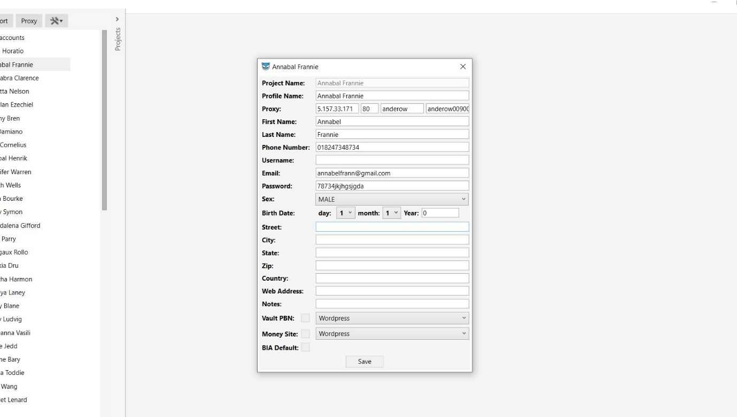

This is the profile exporter, I removed unused fields from the export (mainly). You can find the exported csv in the zip BrowseoCSVExport_14_05_2020 22_46_24_